Arra Server Control System
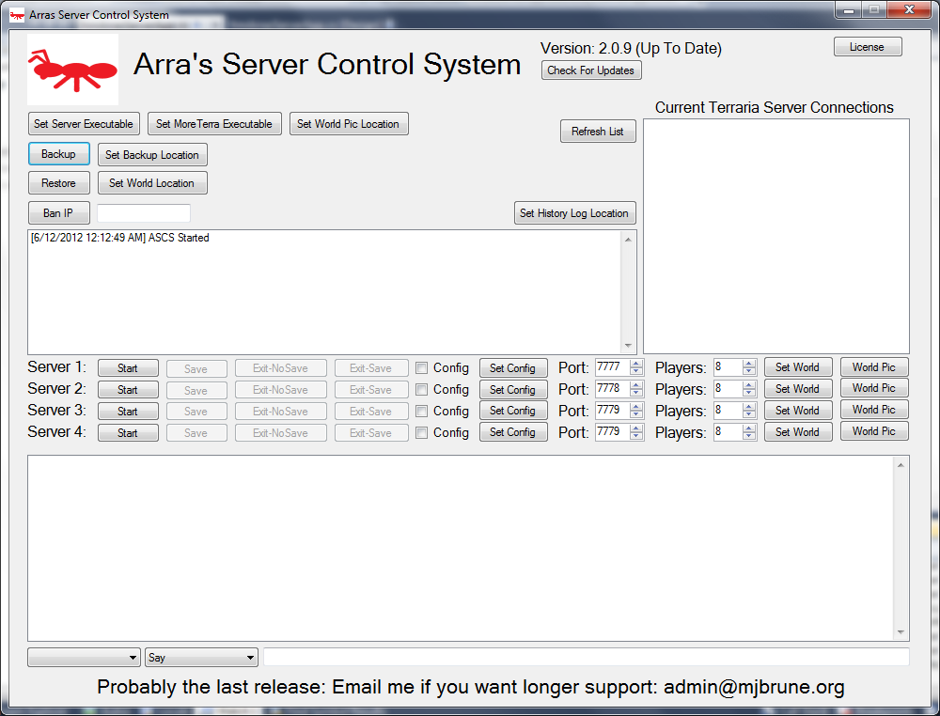
Overview: ASCS is a server manager for the game Terraria a popular 2D minecraft-like game. The Terraria server system is a command line application which had no easy way to manage multiple servers. Adding a simple GUI and adding features like a one click world viewer and a simple backup/restore system provided the users with an easy application that didn't require 4 command windows to be open all the time. Ease of use for the user was stressed when designing this application because a lot of gamers aren't the system administrators that a command line application demands.

History: Below is the code history which I try to keep with my code at all times.
* 01/06/2012 - Felt self-conscious about my code, cleaned it up as best as possible.
* 01/05/2012 - Added more support for setting paths such as set backup path and worldlocation.
* 01/05/2012 - Added MoreTerra support.
* 01/04/2012 - Removed TCPVCON requirements by parsing the server output
* this means that users can't use the playing command.
* 01/04/2012 - Added try/catch to each server thread.
* 01/04/2012 - Added a license that requires a changelog.
* 01/03/2012 - Added Updater. As well as SetServerExe and Save buttons.
* 12/30/2011 - Version 2.0.0 Released.
* 12/15/2011 - Version 1.0.0 Released. Inital functions working.
On 01/05/2012 I stopped continued development for the application as I had completed it to the clients liking.

Experience:
- Threaded processing
- Thread delegation
- Process I/O redirection
- C# Webclient
- Version announcement

